HOW TO UNPROTECT AND PROTECT A WORD DOCUMENT
To unprotect a protected word document click on the Review tab at the top of the page:
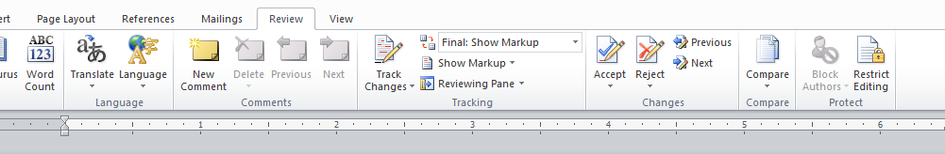
This will open several menu “buttons”: click on the one to the far right labeled “Restrict Editing”
This will open a side screen to the right of the page that looks like this:
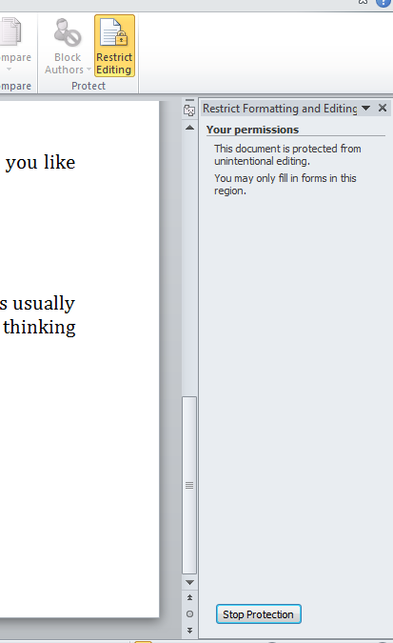
On this screen click on the “Stop Protection” button that appears near the bottom of the side screen.
This view will now appear on the side screen:
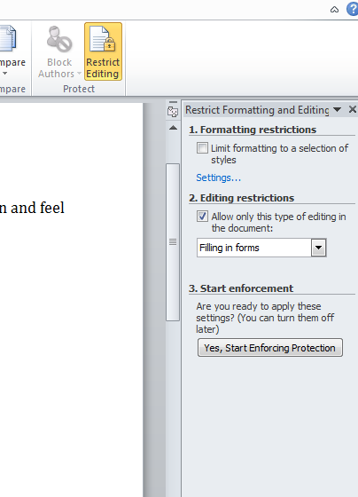
The document is now UNPROTECTED. You will now be able to manipulate the document and add/copy/paste into the document. The text boxes WILL NOT WORK while the document is unprotected.
When you are ready to PROTECT the document, be sure the editing restrictions box reads “Filling in forms” and then press the button that reads “Yes, Start Enforcing Protection”
A box will now appear in the center of your screen:
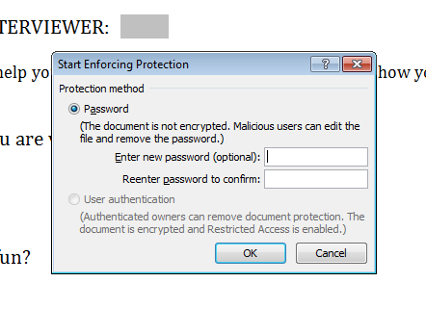
You can leave the password boxes blank; they are optional. Click on the “OK” button. The document is now PROTECTED. You can now close the side screen by clicking on the “x” in the upper right hand corner of the side screen. Your document will return to a full screen view:
