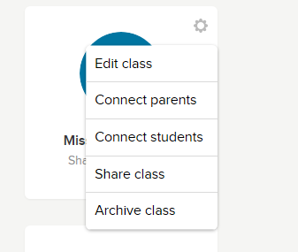

Then, click here on share class

Click here in this little wheel

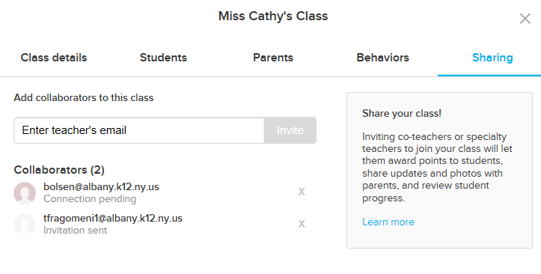

Then enter my email here:

Chuttner@albany.k12.ny.us