How to send an email directly from google sheets with a copy to sender
Step 1: Click on file drop down and click on email collaborators
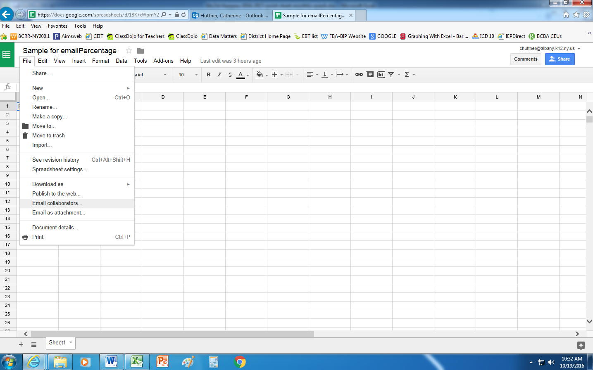

Step 2: Email window will open
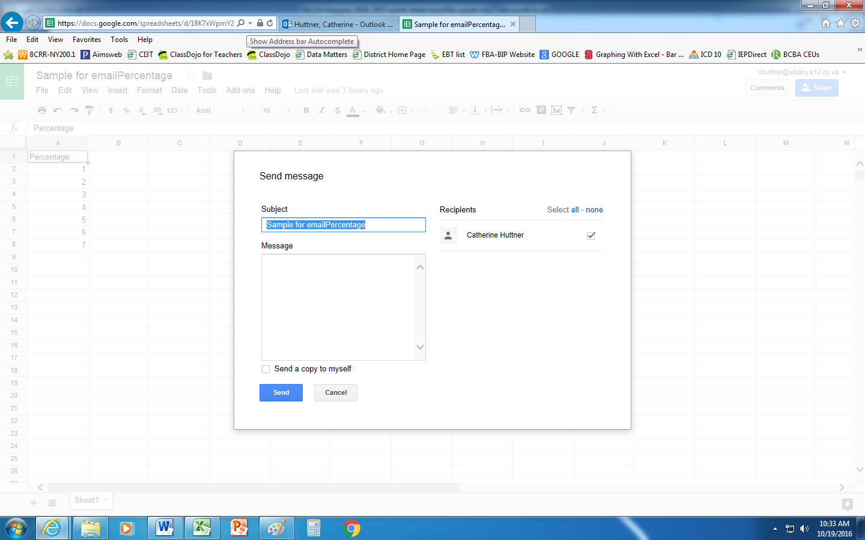
Step 3: Enter subject, recipient, enter message and click “Copy to myself” before hitting send
