FUNCTIONAL BEHAVIORAL ASSESSMENT
ALBANY CITY SCHOOL DISTRICT
(Version 6/2017)

ALL SUPPORTING DOCUMENTS NEED TO BE SCANNED AND SAVED TO APPROPRIATE SHARED DRIVE (BUILDING RTI, Sp. Ed.) &/or FRONTLINE IEP

STUDENT NAME: XXXX XXXX-XXXX |  |  |  | STUDENT DOB: 09/06/2011 |  | STUDENT ID: XXXXXX |  | FBA CONSENT DATE: 1/24/XX  (End Date: 3/9/XX)
CHRONOLOGICAL AGE: 6 | DOMINANT LANGUAGE: English |  | ENL?  YES NO |  |  | SCHOOL:
 |  |  |  |  |  | GRADE:
NAMES AND TITLES OF INDIVIDUALS COMPLETING FBA (ONLY LIST THOSE THAT WERE INVOLVED IN THE FBA PROCESS)
SPECIAL EDUCATOR: XXXX  SOCIAL WORKER: XXXX  PSYCHOLOGIST: XXXX  PARENT:  GENERAL EDUCATORS (LIST ALL): |  |  |  |  | ADMINISTRATOR:  BEHAVIOR SPECIALIST: XXXX  TEACHER ASSISTANT/AIDE:  RELATED SERVICE PROVIDERS (LIST ALL):  OTHER:
IS STUDENT CSE IDENTIFIED? YES NO |  | IF IDENTIFIED – CLASSIFICATION: |  |  |  |  | CLASS PLACEMENT: 12:1:2 |  | 504? YES NO

SECTION 1: EVALUATION OF TARGET BEHAVIOR
TARGET BEHAVIOR: Disruptive behavior defined as out of seat/area for more than 5 seconds without adult permission and/or loud noise making in excess of 2 seconds that persists following 1 adult prompt to sit (or to walk if out of seat with adult permission) quietly. These behaviors are observed to occur as the start of a behaivoral chain that can lead to physically aggressive behavior.

DESCRIBE THE INTENSITY OF TARGET BEHAVIOR BASED ON THE RUBRIC BELOW: Based on teacher interview, the target behavior (disruptive behavior) ranges from a 3 to a 4 on the intensity scale below. However, physically aggressive behavior is at times the result of a behavioral chain starting with disruptive behaivor; instances of physical aggression when they occur rank as a 5 on the intensity scale below.

Intensity Rubric
Intensity Rating | Definition |  | Example
1 | Behavior is confined only to the observed student. |  | May include such behaviors as: refusal to follow directions, scowling, crossing arms, pouting, or muttering under his/her breath.
2 | Behavior disrupts others in the student’s immediate area. |  | May include behaviors such as slamming textbook closed, dropping book on the floor, name calling, or using inappropriate language.
3 | Behavior disrupts everyone in the class |  | May include behaviors such as throwing objects, yelling, open defiance of teacher directions, or leaving the classroom.
4 | Behavior disrupts other classrooms or common areas of the school |  | May include behaviors such as throwing objects, yelling, open defiance of school personnel’s directions, or leaving the school campus.
5 | Behavior causes or threatens to cause physical injury to student or others |  | May include behaviors such as display of weapons, assault on others
EVALUATE PATTERNS OF TARGET BEHAVIOR BY TIME OF DAY, LOCATION, ACTIVITY, ETC. USE ANY OF THE FOLLOWING DATA SOURCES (CHECK ALL THAT APPLY):
SCATTERPLOT INTERVIEW (With: ) POINT SHEETS OFFICE REFERRAL SUMMARY FORM VADIRS
OTHER: Student Support Team (SST) Log; Target Behavior Data collection by partial interval measure

Tier 1 Daily Point Sheet Data (Graph below) - A 10-day sample of Tier 1 Daily Point Sheet data was used to assess if any correlation can be found between overall challenging behaviors (i.e., behaviors that are inconsistent with Tier 1 behavioral expectations) and time of day, concurrent demands and/or peer/staff grouping. This sample shows a declining trend over the course of the school day in XXXX’s ability to demonstrate behaviors consistent with Tier 1 behavioral expectations with the first half of the day (Intervals 1 through 4) earning an average of 37% of points possible and the latter half of the day (Intervals 5 through 8) earning an average of 18% of points possible; a differential of 16 points. Morning activities/demands in this sample included: ELA, Morning Circle, 4 specials (music 1x, PE 3x), lunch and recess. Afternoon activities/demands across this sample included Math, Socialization (end of day), Lunch, Recess, and 7 specials (art 3x, library 2x and gym 2x) Consideration should be given to possible time of day effects of medication therapy that XXXX was receiving during the period from when this sample was drawn.

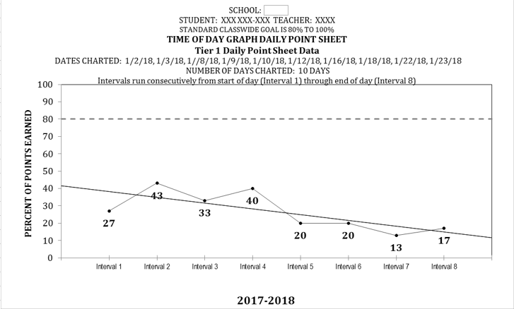

Student Support Team (SST) Logs (Graph below) - SST logs were analyzed for the school year September through January. This found a pattern of increasing trend by number of minutes XXXX is spending out of instruction and in the SST suite for behavioral management support. This finding supports the teacher’s current concern that XXXX is increasingly unavailable for instruction in the classroom due to behavior management needs. In addition to an overall increase month to month in the number of minutes spent in the SST suite, there is an increase month to month in the number of visits each month XXXX has to the SST suite from class (September – 5 visits, October – 7 visits, November – 4 visits, December – 8 visits and January – 8 visits). Overall, the time of the day when XXXX was most likely to be removed from class to the SST suite over this 5-month sample was between 8:00 and 9:30 (12/31 or 39% of removals) although removals at this time of day appear to have decreased since his mother has begun transporting him to school instead of sending him on the bus. Staff observe that as a result of this change XXXX has had a quieter entry most mornings.

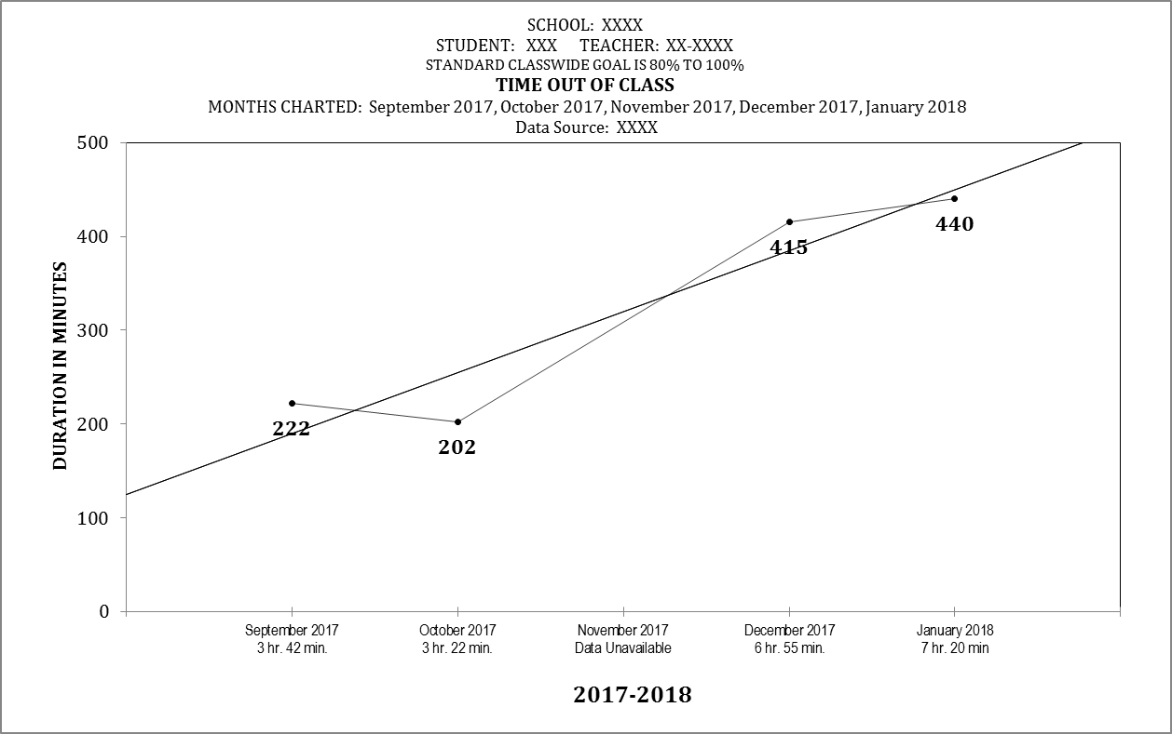

Data Collected on Target Behavior (Partial Interval Recording) by Time of Day (Graph below) - Partial interval data collected on the target behavior when evaluated in half hour intervals over a 5-day sample shows no clear trend by time of day apart from a marked higher rate of occurrence during the 8:30/9:00 interval and a 0% rate of occurrence at the end of the day during the 2:00/2:30 interval
.
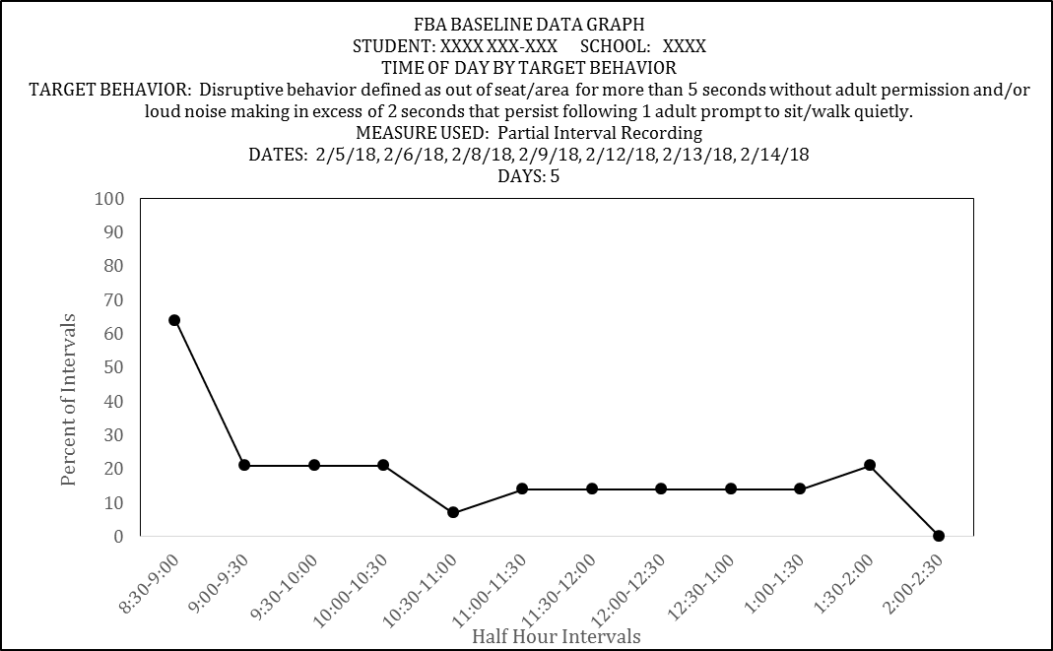

Time out room use by month (Graph below) - XXXX has used the Time Out Room at YYYY on only one occasion to date this school year through the months (inclusive) of September 2017 through February 2018. His use of the Time Out Room has only occurred recently for the first time (February) and may be consistent with the increasing trend found in occurrence of the target behavior (see graph below, Section 4). Given this recent use, his use of the Time Out Room will continue to be monitored

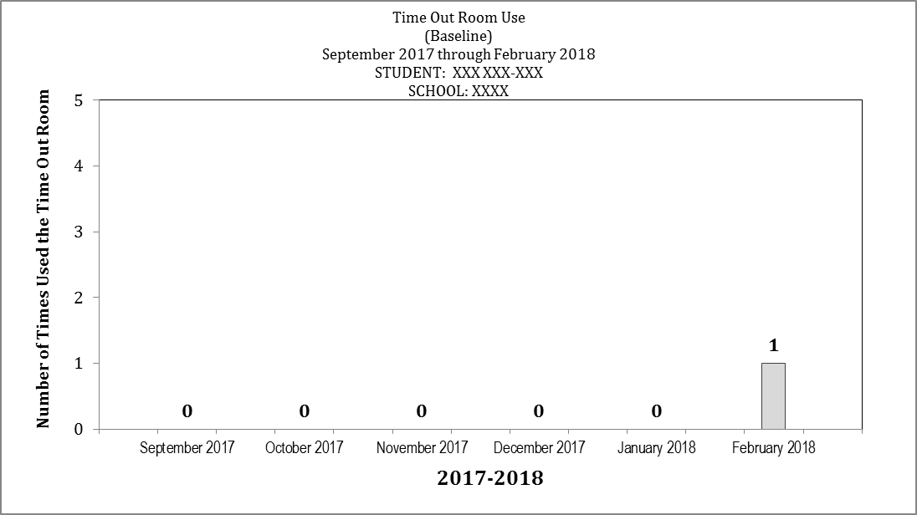

THE TARGET BEHAVIOR IS MOST LIKELY TO OCCUR:  - WHERE (LOCATION): In the classroom  - WHEN (TIME OF DAY/ACTIVITY/CLASS): Between 8:30/9:00, 12:01/12:30 and 1:16/1:45; in noisy environments, in environments of low attention; at times when denied access to a preferred activity; during less structured activities such as gym  - WITH WHOM (PEERS/ADULTS): XXXX and peers in class |  | THE TARGET BEHAVIOR IS LEAST LIKELY TO OCCUR:  - WHERE (LOCATION): In the cafeteria  - WHEN (TIME OF DAY/ACTIVITY/CLASS): Midday between11:30/12:00 and 2:00/2:30; during lunch in the cafeteria; in ISS; in the classroom when there are less students or when the classroom is empty of students and XXXX has access to 1:1 quiet time with the teacher  - WITH WHOM (PEERS/ADULTS): XXXX (Home School Coordinator)

SECTION 2: EVALUATION OF CONTEXTUAL FACTORS
COGNITIVE ABILITIES
YES | NO | Does this impact the TARGET BEHAVIOR? If yes, please explain:
 |  | EXECUTIVE FUNCTIONS (flexibility, metacognition, impulsivity, inattention/distractibility, persistence, problem-solving, etc.): XXXX presents with impulsive and distractable behaviors as compared with same age, same sex peers in class. These behaviors appear consistent with his diagnosis with an Attention Deficit Hyperactivity Disorder (ADHD, see Medical Status, below). His mood is observed to be labile with unanticipated changes. He can also present as inflexible in accepting redirection to non-preferred tasks. An adult setting a limit on XXXX's access to a preferred activity or task can result in XXXX engaging in disruptive behaviors; at times this can also lead to XXXX engaging in aggressive behaviors.
 |  | LANGUAGE (expressive and/or receptive): Based on classroom observations and compared to same age, same sex peers XXXX appears to have language skills within normal limits. He does not receive speech therapy. On the Celf-2 Preschool administered May 2016 XXXX obtained a Core Language score of SS 84. At this time, he is observed in the First grade 12:1 class to be able to express his wants and needs verbally.
 |  | WORKING MEMORY: Based on classroom observations and as compared to same age, same sex peers in class XXXX appears to have working memory skills consistent with his peers.
 |  | MOTOR (gross and/or fine): XXXX receives occupational therapy (OT) services to support fine motor skills development. However, per teacher observation, XXXX's fine motor skills deficit does not appear linked to the occurrence of the target behavior.
 |  | SENSORY (sensory-seeking, sensory-avoidant): XXXX may be sensory seeking or avoiding in his behavior as hypothesized by a high rate of noise making behavior as compared to same age, same sex peers observed concurrently in the classroom setting. This observation is supported by a diagnosis made by his physician of a sensory processsing disorder (see Medical Status, below). However, a recent Occupational Therapy (OT) Screening completed 2/10/16 found that, while sensory differences did exist on evaluation, "no extereme sensory concerns (were) noted". The report did list strategies, some of them sensory, that might help XXXX experience more success in the classroom. Currently, XXXX recieves school-based OT services.
 |  | PROCESSING SPEED: Based on classroom observations and as compared to same age, same sex peers in class, XXXX appears to have processing speed within normal limits.
AFFECTIVE ABILITIES
YES | NO | Does this impact the TARGET BEHAVIOR? If yes, please explain:
 |  | MOOD (predominant or cycling): Mood is often labile and unpredictable. This appears consistent with his diagnosis with an Other Mood Affective Disorder (see Medical Status, below). This mood lability and unpredictability has a significant impact on XXXX's ability to function calmly within the classroom environment and to manage frustration without escalation in mood. XXXX currently recieves school-based Psychological Counseling per his IEP.
 |  | EMOTIONAL SELF-REGULATION: XXXX has difficulty independently self-regulating his emotional and behavioral responses to stressors without 1:1 adult assistance. At times, even when provided with 1:1 adult assistance, he still has difficulty in regulating his emotional responses to stressors.
 |  | FRUSTRATION TOLERANCE: XXXX has poor frustration tolerance as compared to same age, same sex peers observed in the classroom. This appears consistent with his diagnoisis with an Oppositional Defiant Disorder (see Medical Status, below). He becomes frustrated more quickly with a task than peers observed concurrently and is observed to have fewer resources than peers for resolving his feelings of frustration (i.e., asking for help from an adult, persisting despite frustration, flexibly using alternate problem solving, use of self talk, etc.)
 |  | SOCIAL SKILLS: XXXX's ability to successfully utilize the social skills he has appears impaired by his inability to self-regulate his emotional responses and manage frustration. Based on the Social Skills Improvement Scale (SSIS), XXXX scored in the Average range in the areas of Communication and Empathy, compared to peers of his same age and gender. He scored Below Average in the areas of Cooperation, Assertion, Responsibility, Engagement, and Self-Control. XXXX scored a standard score of 64, on the Social Skills Scale. On the Problem Behavior scale, XXXX's standard score was 139. He scored in the Above Average Range in the areas of Externalizing, Bullying, and Hyperactivity/Inattention. He scored in the average range, in the area of Internalizing.
MEDICAL STATUS
YES | NO | Does this impact the TARGET BEHAVIOR? If yes, please explain:
 |  | PHYSICAL/HEALTH CONCERNS/MEDICAL DIAGNOSIS: By parent report on 2/8/18, XXXX is most recently diagnosed by current outpatient mental health provider with Attention Deficit Hyperactivity Disorder (ADHD), Oppositional Defiant Disorder (ODD), Other Mood Affective Disorder and Sensory Processing Disorder (alternately described on XXXX's IEP as Sensory Integration Dysfunction) . XXXX currently participates in outpatient mental health counseling and medication management through Parson's Child and Family Guidance Clinic in Albany, New York.

SECTION 3: SUMMARY OF INDIRECT OBSERVATION DATA
This is a SUMMARY section. SUMMARIZE each of the following supporting documents. Do not rely on a reference to an attachment
STUDENT INTERVIEW
XXXX believes that he is good at doing "terrific work", computer time, and computer lab. He enjoys playing with toys, mixing foods, helping to make pizza, playing on his X-Box and watching movies. He has identified 4 students who he considers friends, and 3 adults who enjoys being with because they help him (teacher and TAs). Some of his favorite things to do in school, are to work on the computers and tablets, play time, and to work on Big puzzles. When asked about schoolwork, XXXX reports that he does not like I-Read. He identifies that he can get help with work that is challenging, by saying 'Please'. XXXX likes people coming over to him and saying, "wow, good job XXXX!", and to give him a High 5. He wants to earn puppets if he has done a good job. He does not know why he exhibits the target behavior, but says that he gets upset when he doesn't want to do work. He feels that he wants to get more sleep at night.

TEACHER(S) INTERVIEW(S)
XXXX reports that XXXX engages in disruptive behaviors (operationally defined above as the target behavior) across settings. This includes occurences during both non-academic demand times, such as Physical Education (PE) and the Cafeteria, and also during academic demand times in class, such as Math and ELA instructional times. Anecdotally, XXXX observes that XXXX engages in relatively higher rates of disruptive behaviors in less structured settings, such as morning entry. XXXX reports that occurrence of disruptive behaviors does not appear to be linked with any particular adult noting occurrence seems to happen equally in the presence of any/all teachers with the exception of XXXX, the Home School Coordinator (HSC). XXXX reports that, when with XXXX, XXXX appears to engage in disruptive behaviors less often. Many times, these are circumstances of 1:1 contact that occur after XXXX has been removed from the classroom due to disruptive or aggressive behavior. Triggers to disruptive behavior, in addition to less structured times of day, are reported by XXXX to include adult redirection, adult demands and loud noises. XXXX reports that disruptive behaviors often lead to instances of XXXX engaging in physically aggressive behaviors towards either peers or staff. Academically, XXXX is now demonstrating deficits relative to peers as seen in recent benchmarking on both Phoneme Segmentation and Nonsense Word Fluency measures (see graph below). However, this appears to be a change from his achievement on the same measures as administered last year when he was a Kindergarten student. XXXX observes that XXXX is now frequently refusing to join instructional groups. She observes that his refusal to engage in instruction has likely contributed to his growing academic needs. Specifically, XXXX has demonstrated a relative drop in benchmark scores this year from last year on measures of Letter Sound Fluency (LSF) and Nonsense Word Fluency (NWF). Phoneme Segmentation Fluency (PSF), administered for the first time this school year, shows XXXX scored below expectations for grade. XXXX hypothesizes that XXXX's growing refusal to join instructional groups, his refusal to complete academic activities, his increasing behavioral needs and subsequent increasing removals from class are increasingly interfereing with his availability for instruction. This hypothesis additionally appears supported by the analysis done (above - Section 1) of the SST logs showing an increasing trend in removals from class for behavioral management support.
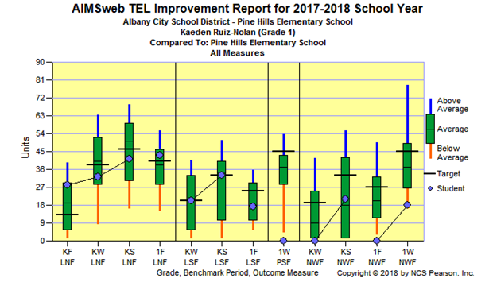
REVIEW OF RECORDS
XXXX has attended YYYY for the past two years. He has been educationally placed in the 12:1:2 program. XXXX attended an intergrated preschool program within the ACSD at NAA. XXXX does have an increased number of absences, but this are due to medical appointments, suspensions, and/or crisis situations. When healthy, XXXX attends school regularly. He carries the mental health diagnoses of ADHD, ODD, and sensory dysregulation. These mental health disorders are treated medicinally. Medication is administered at home and school. XXXX recieves his counseling through Parsons Family and Child Center. Academically, XXXX is performing below grade level. XXXX may possess more academic skills than he demonstrates but behaviors interfere with learning. XXXX requires an increased amount of coaxing to engage in learning. He also spends an increased amount of time out of the classroom which also impacts progress. XXXX does benefit from individualized educational goals and related services.

PARENT/GUARDIAN INTERVIEW
Parent interview was completed on 2/8/18, with student's mother, XXXX XXXX. Parent reports that her current concerns regarding XXXX's behavior are: violent behaviors, screaming, being defiant/non-Complaint. These behaviors usually occur when he is told 'No', if he is redirected, when there are a lot of people/noise around him or when his favorite activities are disrupted. Student is currently receiving both school-based and out-patient counseling services and out-patient medication management through Parsons Child and Family Guidance Center in Albany, NY. Current diagnoses are: Asthma, ADHD combined type, ODD, Sensory processing disorder and Other Mood Affective Disorder. Parent reports XXXX is currently being prescribed a course of medication therapy for treatment of psychiatric diagnoses. Parent reports that prior to XXXX's father no longer being in his life XXXX's behaviors were more manageable. Parent reports delays in language development and a family history of both learning disabilities and mental illness.

SECTION 4: SUMMARY OF DIRECT OBSERVATION DATA
Baseline Data Collection Method
SELECT ONE MEASURE – DOCUMENT A MINIMUM OF 8 DATA POINTS
TIME SAMPLING  (CHECK ONE)  WHOLE INTERVAL  PARTIAL INTERVAL  MOMENTARY |  | FREQUENCY DATA | DURATION DATA | LATENCY DATA
QUANTITATIVE Summary of Baseline Data
Observations were conducted in both problem and non-problem settings: YES NO
Summary of findings: Data were collected on the target behavior using a full-day 15-minute partial interval measure. Baseline data were collected over 10 school days. Over this 10-day period the target behavior was found to occur on an average of 45% of intervals observed with a range of occurence between 21% and 67% of intervals observed. Overall, an increasing trend was seen in the occurrence of the target behavior over this 10-day baseline sample (see graph below).
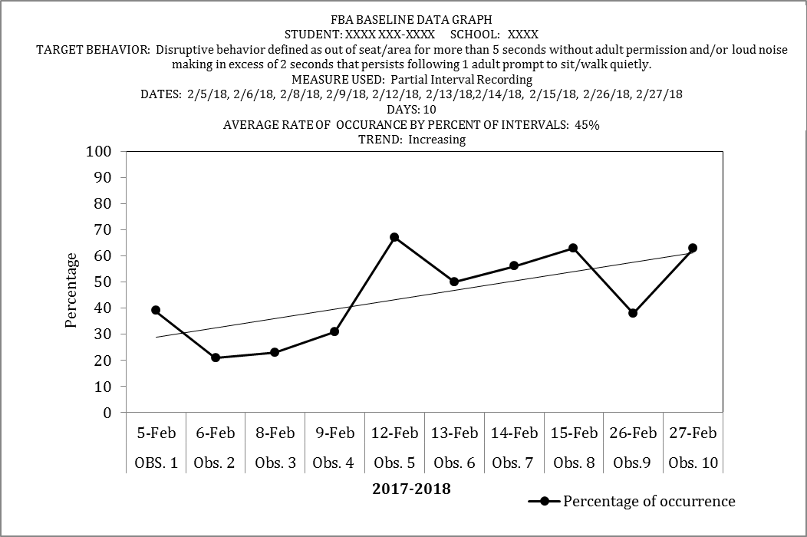

Optional Additional and Supplemental Baseline Data
PERMANENT PRODUCT  TIME SAMPLING | Summary of findings: Occurrence of aggressive behavior will be monitored as a secondary supplemental measure. It is hypothesized that aggressive behavior is the end result of a behavioral chain typically starting with occurences of disruptive behavior. It is important to decrease the occurrence of both disruptive behaviors and the occurrence of aggressive behaviors. The team has decided to work to decrease disruptive behaviors with the intent that, by decreasing occurences of disruptive behaviors, a decrease will then be seen in the subsequent occurence of aggressive behaviors. Data collection on instances of aggressive behaviors was done using a full-day 15-minute partial interval measure. Baseline data were collected over 10 school days. Over this 10-day period physical aggression was found to occur on an average of 14% of intervals observed with a range of occurrence between 0% and 40% of intervals observed. Overall, a slight increasing trend was seen in the occurrence of physical aggression over this 10-day baseline sample (see graph below).
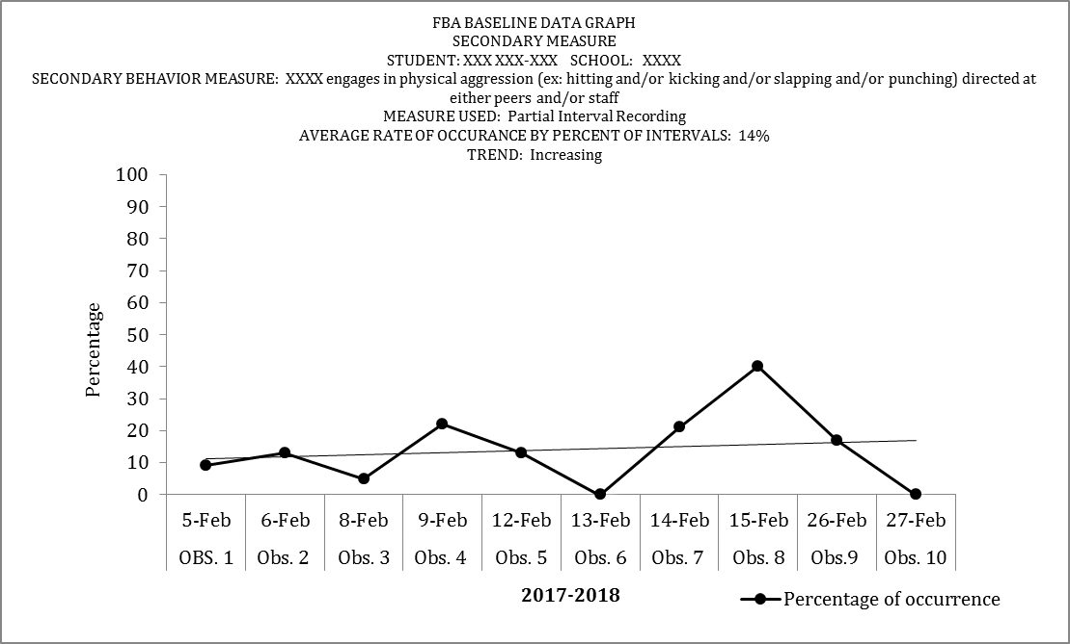

SECTION 5: HYPOTHESIS
Complete following section using Antecedent-Behavior-Consequence data
What antecedents occurred before the target behavior?  Summary of findings:  Ten instances of ABC data was collected between 2/8/18 and 2/15/18. Antecendent events over those observations included instances of:  -XXXX attempting to engage a peer in the classroom (3 instances)  -Running in PE (1 instance)  -Individual play (2 instances)  -Large group instruction on rug (1 instance)  -Transition into class during small group instruction (1 instance) | TARGET BEHAVIOR  (Copy and paste your Target Behavior here)  Disruptive behavior defined as out of seat/area for more than 5 seconds without adult permission and/or loud noise making in excess of 2 seconds that persists following 1 adult prompt to sit (or to walk if out of seat with adult permission) quietly. |  | What consequences occurred after the target behavior?  Summary of findings:  Over 10 instances of ABC data collected the following consequences were seen:  -70% of instances resulted in XXXX obtaining attention from either a peer or an adult  -30% of instances resulted in XXXX obtaining a tangible (preferred activity)  (Obtain) Attention appears to be the most likely function associated with occurrence of the target behavior (70%). The team will proceed with the development of interventions aligned with this function and will consider interventions aligned with the hypothesized function of (obtain) tangibles following evaluation of intervention on the hypothesized function of (obtain) attention
What is the function of the target behavior?
Select a minimum of 1 function – if select more than one function, interventions must address both functions
TO GET:  ATTENTION (ADULT/PEER)  TANGIBLE (OBJECT/ACTIVITY)  SENSORY |  | OR |  | TO AVOID/ESCAPE:  ATTENTION (ADULT/PEER)  TANGIBLE (OBJECT/ACTIVITY)  SENSORY
Hypothesis Statement
WHEN THIS OCCURS (describe the circumstances/setting events) In environments of lower attentiion and/or less structure, upon arrival to class and in noisy environments or, to a lesser extent, at times when denied access to a preferred object or activity

THE STUDENT DOES (describe the target behavior) XXXX will engage in disruptive behavior defined as out of seat/area for more than 5 seconds without adult permission and/or loud noise making in excess of 2 seconds that persists following 1 adult prompt to sit (or to walk if out of seat with adult permission) quietly. These behaviors are observed to occur as the start of a behavioral chain that can lead to physically aggressive behavior.

TO GET/AVOID (describe the consequences) Most typically, XXXX obtains attention from engaging in this behavior. Less frequently, XXXX obtains a tangible object or activity from engaging in this behavior.

SECTION 6: ASSESSMENT OF STUDENT PREFERENCES FOR REINFORCEMENT
What assessment(s) was used to determine student preferences for reinforcement? Check below.
Forced Choice Reinforcement Menu Student Reinforcement Survey If no student participation, specify reason:
INCENTIVES (Summarize results): On the Reinforcer Preference Survey administered 2/6/18 XXXX was found to prefer most, in rank order:  Social reinforcers (100% of choices offered)  Tangible reinforcers (100% of reinforcers offered)  Activity reinforcers (100% of choices offered)  Edible reinforcers (90% of choices offered) | DISINCENTIVES (Summarize results): On the Reinforcer Preference Survey administered 2/6/18 XXXX was found to least prefer:  Academic reinforcers (75% of choices offered)

SECTION 7: DOES THIS STUDENT’S BEHAVIOR WARRANT A BIP BASED ON FBA INFORMATION COLLECTED & ANALYZED?
MEETING DATE: 3/15/18
ATTENDANCE: XXXX XXXX (CSE), XXX XXXX (Teacher), XXX XXXX (Social Worker), XXXX XXXXX (School Psychologist), XXX XXXX(Occupational Therapist), XXX XXXX (District Assigned Social Worker), XXXX XXXX (Parent)

MEETING DECISION
NO  IF NO, YOU DO NOT NEED TO CONTINUE WITH THE REMAINDER OF THE DOCUMENT. PLEASE PROVIDE A BRIEF SUMMARY STATEMENT OF WHY YOUR FINDING IS THAT A BIP IS NOT INDICATED AT THIS TIME: | YES  IF YES, PLEASE CONTINUE WITH REMAINDER OF THE FBA DOCUMENT

SECTION 8: RECOMMENDATIONS FOR TEACHING ALTERNATIVE SKILLS OR BEHAVIORS
REPLACEMENT BEHAVIOR: XXXX will ask to spend time with an adult or peer (the teacher will tell XXXX which peer or adult is available at the time of this request, duration of time an adult or peer will spend with XXXX will vary depending on availability and activity in class at the time)
GOAL BASELINE: XXXX's rate of disruptive behavior (as defined) will decrease to an average rate of occurrence of 20% of intervals or less measured over 3 consecutive weeks with a concurrent decrease in rate of aggressive behaviors (as defined) to an average rate of occurrence of 5% of intervals or less measured concurrently over 3 consecutive weeks.
SETTING EVENT STRATEGIES:  -Head phones will be made available to XXXX prior to entry into a noisy environment  -Close proximity to an adult and/or 1:1 adult support whenever available in the classroom  -Upon entry in the morning daily XXXX will have a 5 to 10 minute 1:1 time with an adult to provide non-contingent adult attention and to review social story, First/Then strategies and replacement behavior expectations | STRATEGIES TO TEACH ALTERNATE BEHAVIORS:  -Direct explicit teaching of the replacement behavior. The replacement behavior will be taught to XXXX by the social worker individually in the class using explicit instruction, practice and rehearsal.  -Use of a social story to support direct explicit instruction in the replacement behavior.  -Staff will arrange incidental teaching opportunities throughout the day to prompt the use and reinforcement of the replacement behavior  -XXXX will be taught by social worker and teaching staff to verbally identify a noisy environment and ask for use of headphones.
ANTECEDENT STRATEGIES:  -Rates of adult attention will be increased on an interval schedule using an interval timer.  -XXXX will be individually and positively greeted by an adult upon his return to the classroom following any removal; 1:1 support will be provided to re-enter him into activity choices  -Increase rates of behaviorally stated praise throughout the day for any time spent in seat or in assigned area or for engaging in quiet behaivor.  -Use of First/Then strategies throughout the day and demand situations focused on access to attention and/or tangible as the contingency  -Instructional choice provided in all academic demand situations  -Prompting of option to use head phones prior to any anticipated entry into a potentially noisy environment | CONSEQUENCE STRATEGIES:  -Immediate reinforcement paired with behavior specific praise: Use of the replacement behavior will result in both behavior specific praise and the adult immediately sitting with XXXX or allowing access to peer attention (for short periods of time IF access to peer attention is consistent with availability and activity in class)  -When XXXX engages in the target behavior planned ignoring will be used with immediate contingent attention and the use of behaviorally stated praise provided when the target behavior stops (initially even for approximations of desired behaivors).  -Planned ignoring should not be used when XXXX engages in any behavior that is unsafe to self or others.  -In the event of unsafe behaviors staff should use Theraputic Crisis Intervention in Schools (TCIS) descalation strategies.  -Use of time out room as consistent with City School District of Albany policy and procedures

