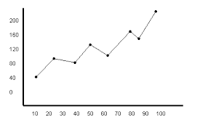 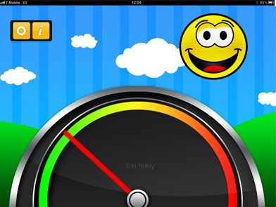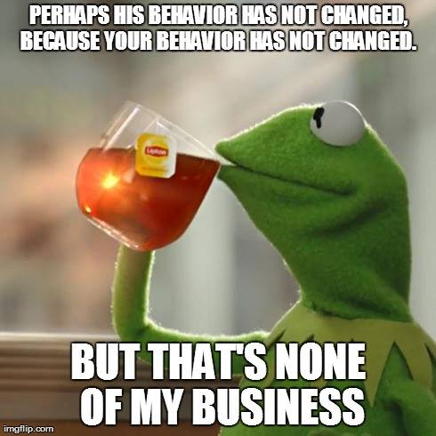

**IMPORTANT FBA/BIP UPDATES & CHANGES**

REMEMBER: It is no longer REQUIRED to have an FBA/BIP for every student classified with “Emotional Disturbance”.

FBA’s and BIP’s can now be saved to the **IEP Direct Document Repository** for students classified with a disability. Progress Monitoring data can be saved there as well as it is completed or by the end of the school year.

***DID YOU KNOW?***

The website offers downloadable excel graphing options for **Progress Monitoring** that are prepared with all 2014-2015 dates already entered?

These include graphing options that let you enter percentage or frequency data by time of day or day of the week or by discrete trial.

**If you want help developing a customized graph contact Cathy Huttner**

**READ THIS**

**Behavior Management**

March 2015

Volume 1, Issue 3

Editors: Brianna Olsen & Cathy Huttner

**CONTENTS**

**On-Line Resources Review:**

Too Noisy App (p. 2)

**TRY THIS Behavior Change Strategy:**

The Good Behavior Game (p. 2)

Interview With A Behavioral Innovator (p. 3)

Food For Thought – p. 4

Ideas for Free Incentives –p.4

City School District of Albany

“Nothing changes if nothing changes”

ELEMENTARY

Link to district Tier III website

<http://acsd-fba-bip.weebly.com>

City School District of Albany’s Behavior Management Newsletter Publishing issues in September, December, March and June, shares resources and best practices that can assist staff in increasing their skill set specific to behavior management issues.

Forward your article, resource reference or idea(s) to either Brianna Olsen ([bolsen@albany.k12.ny.us](mailto:bolsen@albany.k12.ny.us)) or Cathy Huttner ([chuttner@albany.k12.ny.us](mailto:chuttner@albany.k12.ny.us)).

**BEHAVIOR CHANGE STRATEGY**

**The Good Behavior Game (GBG)**:

# Few educational professionals are aware of this concisely structured and easily implemented whole-class behavior management system.  Fewer still know how to go about making use of it.  It is the rare educator who has implemented it. Strange, as it is among the most research-supported entire-classroom behavior management processes available to us. “Few interventions… have been researched as much, as often, and across as many diverse settings as the Good Behavior Game.” (Elwick & Casey, 2011, p. 36)  The GBG has been replicated with different age groups, special needs populations, geographic areas with different population densities, and internationally, thus “…increasing the likelihood that the GBG will work in almost any setting, with any age group, and with any population.” (Elwick & Casey, 2011, p. 37) The Coalition for Evidence-Based Policy lists the GBG on its list of “Social Programs that Work”.  In essence, the Good Behavior Game is a proven system that can be implemented for a large part of the day in primary/elementary schools, class periods in secondary schools, or specific activities during which you wish to have your students engage in cooperative teamwork.”*

# *Thanks to Dr. Mac for this summary and click here to learn more about this easy-to-implement effective practice: <http://behavioradvisor.com//Teacher-SchoolServices/GoodBehaviorGame.html>..

# The GBG is also reviewed in the Big Red Book that most district buildings RtI Teams have already purchased as a building resource (“Effective School Interventions, Second Edition: Evidence-Based Strategies for Improving Student Outcomes” by Natalie Rathvon <http://www.amazon.com/Effective-School-Interventions-Second-Edition/dp/1572309679/ref=sr_1_1?ie=UTF8&qid=1406662016&sr=8-1&keywords=rathvon>)

Here is a clip of how the GBG is being used in the Seattle Public Schools They have adapted the game using the local PBIS-language of their district (“ex: “Pax”, “Spleems”, “Toodle Notes”, etc.)

<https://www.youtube.com/watch?v=SdBFa-g2Qts>

ON-LINE RESOURCES REVIEW

**Too Noisy App:**

<http://toonoisyapp.com>

The ‘Too Noisy’ App is a noise-monitoring app for groups of children. There is a free and paid version and is available on the iPhone, iPod Touch, iPad. It can be projected if you have an iPad 2 which would be excellent for classrooms.

On the free version the background picture changes but as teachers know when students get involved in a task, there is no way just a picture will get their attention. That’s why you may want to look at the pro version called ‘Too Noisy Pro.’  It has the same background but when the noise gets too loud it looks like the screen cracks and it has a loud noise to get the attention of the children. This will reinforce the acceptable noise level and remind them of it. The pro version also has a counter. This would be great as a way to create incentives linked to self-control of volume level for example, if the alarm only goes off once during math we’ll have a 5-minute dance party. That way it is reinforcing the noise level expectations and the teacher is clearly stating the expectations.

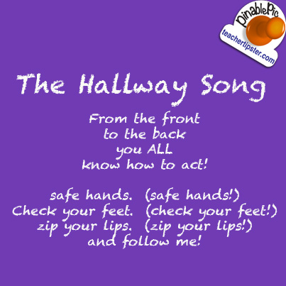

Christina Harkavy, Special Educator, Giffen Elementary School, 8:1 K-1

Chris has been teaching in the district years.

We interviewed her recently to hear about some of her management practices:

**US**: Chris, what would you describe as your most effective management strategy?

**CHRIS**: Our class wide behavior plan is by far our most effective management strategy. Each student has a Daily Point Sheet that monitors and asks the questions every half hour throughout their day including; Are you being Safe, Are you being Respectful, Are you being Responsible? This is part of our school wide PBIS program of which our class has had at least half participate in our monthly celebrations! Our students have participated successfully in the teaching and re-teaching days of behavioral expectations, particularly for the hallways and the learning space. Our staff provides additional re-teaching and practice of these expectations as needed.

For those behaviors that present as needing Tier 3 interventions, the Target Behaviors of the FBA's are progress monitored and appropriate and often-creative interventions are provided. As motivation is a key factor for successful student behavior we provide multiple opportunities to earn additional tangible materials and special visits throughout the school day.

**US:** Do you integrate behavioral data into your everyday classroom management?

**CHRIS**: Our classroom routines and procedures are in place, however our instructional length and style change often in the moment based upon behavioral data from the day before and/or our current academic/behavioral observations and needs.

**US**: What has been the biggest challenge you face in bringing effective behavior management practices into the classroom and how have you dealt with that?

**CHRIS**: One of the biggest challenges I face in bringing effective behavior management practices into the classroom is recognizing that as a team we need to remain clear and consistent with our students while providing a therapeutic environment that supports their daily changing needs. I believe as all educators we feel there is not enough hours in the day!

**US**: Are there technology supports that have been helpful in your work on classroom behavior management? If so, what?

**CHRIS**: There are many technology supports that have been helpful in my work on classroom behavior management. These include the data sheets available on the district special education web site that allow us to access and effectively observe and record target behaviors with the purpose of providing appropriate interventions. Additionally, I am able to enter all my students Daily Point Sheets percentages into the Shared Drive and a graph is generated as well*. This has proven helpful at Team meetings and report card conferences.

In terms of incentives and reward time for the students we are able to provide them with earned time on our Netbooks and we are all anticipating the arrival and interactions with our Smart board.

*Direct Link: <http://acsd-fba-bip.weebly.com/progress-monitoring-graphs-2014-2015.html>

**INTERVIEW WITH A BEHAVIORAL INNOVATOR**

**RANDOM QUOTE**

**“Without data you’re just another person with an opinion” – W. Edwards Deming**

If an individual's behavior continues to occur, it is very likely that this is a product of the reinforcing variables in their environment. If we have a close relationship to that individual, it is also very likely that our actions (behavior) may contribute to reinforcing their behavior--as we are a part of their environment. Until consistent change (on our behalf) is maintained in the environment, we are not likely to affect change in their behavior. Therefore, we must always look to ourselves as a possible cause (or reinforcing factor) of the behavior, and not blame the individual if the behavior continues to occur.

WANT SOME IDEAS FOR FREE QUICK INCENTIVES?

**Classroom Break dance videos**

<https://www.youtube.com/playlist?list=PL196E449299AE4E80>

Kid friendly and between 2 and 3 minutes each with dance moves built in

**Flapjack Educational Resources**

<http://www.teacherspayteachers.com/Product/Monster-Themed-Positive-Behavior-Coupons-FREE-266155>

Coupons for privileges

**The Bravo Board**

<http://totallyterrificintexas.blogspot.com/2012/03/bravo-board.html>

Class-wide weeklong competition to “own” the class trophy…and a link for a $6 trophy:

<http://www.orientaltrading.com/gold-trophy-a2-39_2045.fltr?prodCatId=551520>

**DOJO Reward menu**

<http://www.teacherspayteachers.com/Product/Class-Dojo-Reward-Menu-and-Award-Certificate-Pack-599510>

Easy way to tie in if you are already using Class Dojo

**Dice Roll**

<http://www.sandrarief.com/2012/08/15/great-strategy-for-motivating-on-task-behavior/>

Instant incentive for on-task behavior – try it with jumbo dice to add to the fun!

<http://www.orientaltrading.com/api/search?Ntt=jumbo+dice>

FOOD FOR THOUGHT