**Montessori Magnet School**

**C:\Program Files\Microsoft Office\MEDIA\CAGCAT10\j0299125.wmf**

Positive Behavior Interventions and Supports

(PBIS)

2014-2015 Staff Handbook

**Be Safe**

**Be Respectful**

**Be Responsible**

**Be Montessori**

**Montessori Magnet School**

**Positive Behavior Interventions and Supports Team**

Contributors to the development of this handbook and the implementation of this program:

Elnora Baker

Jessica Camardello

Deanna Carras

Danielle Gillespie

Kathleen Higgins

Sue Hodom

Sheryl Huntley

Sarah Rose

Darby Seward

Morgan Short

Linda Weaver

Maura Whalen

Malik Jones, Principal

**Table of Contents**

Introduction to PBIS

What is PBIS?

PBIS at Montessori Magnet

PBIS Parent Brochure

Teaching Positive Expectations

Lesson Plans

Matrix

Discipline Referral Process

Office referral vs. Classroom referral

VADIR Instructions

Helpful Resources

**Introduction to PBIS**

What is PBIS?

School-wide Positive Behavioral Interventions & Supports (PBIS) is a proactive, team based framework for creating and sustaining safe and effective schools. Emphasis is placed on prevention of problem behavior, development of pro-social skills, and the use of data-based problem solving for addressing existing behavior concerns. School wide PBIS increases the capacity of schools to educate all students utilizing research-based school-wide, classroom, and individualized interventions.

PBIS at Montessori Magnet

P.B.I.S is a process that follows a school-wide philosophy that teaches and celebrates positive behavior in our cafeteria, hallways, playground, assemblies, bathrooms, classrooms and on the bus.

The support of PBIS is to promote and maintain an environment that is safe, responsible and respectful at Montessori Magnet School.

The goal is that desired behaviors are consistent among all students and staff at MMS.

**PBIS Parent Brochure**

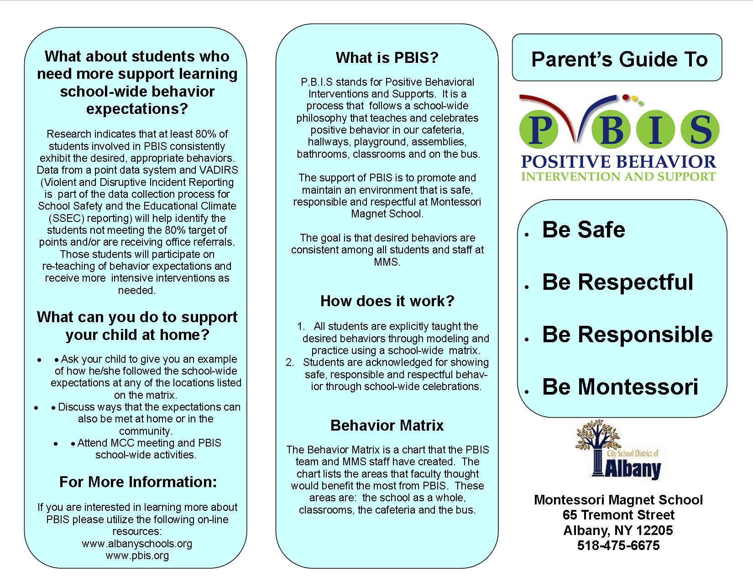

Montessori Magnet School

Expectation Lesson Plans

*Be Safe * Be Respectful * Be Responsible* Be Montessori

Area: Playground Allotted: 10-15 minutes

Materials Needed: None

Review Expectations

|  |  |  |
| --- | --- | --- |
| Be Safe | Be Respectful | Be Responsible |
| Keep hands, feet and objects to self  Move carefully  Play safely  Use equipment appropriately | Use encouraging, polite and kind words  Include others  Good sportsmanship  Share  Take turns  Help others | Accept consequences graciously  Line up when called  Report incident to an adult  Take care of and return playground toys |

Objective: Students will engage in a positive and safe atmosphere on the playground.

Discuss and Model Positive Examples:

* Use appropriate language
* Respect all property
* Follow the rules of the game
* Respect athletic differences
* Include all kids who want to participate
* Keep wood chips and rocks on the ground
* Respect sculpture, pagoda and gardens: these are are for admiring, not playing on or in.

Discuss and Model Negative Examples:

* No playing in the parking lot
* Don’t throw rocks, snow, wood chips or other objects
* No running or tag on playground equipment
* No put downs
* Playing roughly
* Climbing on sculpture
* Retrieving ball in parking lot
* Not lining up when called

Practice the Positive Behaviors

Check for Understanding

Area: Hallway Allotted: 10-15 minutes

Materials Needed: None

Review Expectations:

|  |  |  |
| --- | --- | --- |
| Be Safe | Be Respectful | Be Responsible |
| Keep hands, feet and objects to self  Walk and move carefully | Quite wave  Appropriate voice  Take care of student work materials | Keep hallways clean  Accept consequences graciously  Stay with line  Go straight to destination  Report incident to an adult |

Objective: Students will be able to walk through the hallways safely without disturbing other students.

Discuss and Model Positive Examples:

* Appropriate voice tone in hallway
* Safe hands feet with good body space distance to next person
* Carry all materials quietly in front of you
* Help classmates who drop materials
* Pick up materials/garbage and return to appropriate location
* Go straight to destination
* Report any problems to an adult

Discuss and Model Negative Examples:

* Touching the person in front of you
* Don’t leave gaps in the line stay with the group
* Don’t touch art work hanging in the hall
* Don’t touch run your hands down the wall when walking
* Don’t look into other classes
* No running, skipping, hopping
* No detours to other locations
* Do not use an outdoor voice

Practice the Positive Behaviors

Check for Understanding

Area: Cafeteria Allotted: 10-15 minutes

Materials Needed: None

Review Expectations:

|  |  |  |
| --- | --- | --- |
| Be Safe | Be Respectful | Be Responsible |
| Keep hands, feet and objects to self  Walk and move carefully  Stay at the table  Wait in line patiently | Use encouraging, polite and kind words  Use appropriate voice  Follow adult directions | Keep area clean and throw away trash  Accept consequences graciously |

Objective: Students will experience positive social culture in their eating environment.

Discuss and Model Positive Examples:

* Speak to students at your table with a speaking voice
* Chew with your mouth closed
* Raise your hand if you need help
* Clean up our area
* Treat lunchroom staff with kindness and respect
* Wait to be dismissed by adult
* Stay in your seat
* Use pass to go to the bathroom
* When lights go out there is no voice

Discuss and Model Negative Examples:

* No food taken out of the lunch room
* Don’t leave a mess at your area
* Running in the cafeteria
* Sharing food
* No using inappropriate language
* Talking to student not at your table
* Getting up from the table without permission

Practice the Positive Behaviors

Check for Understanding

Area: Restroom Time Allotted: 10-15 minutes

Materials Needed: None

Review Expectations:

|  |  |  |
| --- | --- | --- |
| Be Safe | Be Respectful | Be Responsible |
| Walk and move carefully  Keep hands, feet objects to self. | Honor others privacy  Speaking voice | Keep area clean  Flush  Wash hands  Report incidents to an adult  Get in and out in a timely manner  Use for intended purpose |

Objective: Students will be use the bathroom appropriately.

Discuss and Model Positive Examples:

• Wait quietly in line for your turn.

• Flush the toilet.

• To wash your hands: turn on the water, 1 pump of soap, and wash for 15 seconds, turn off the water.

• Dry hands using hand dryer or paper towels

* When finished return to class immediately
* Respect other’s privacy
* Throw garbage out in trash or receptacle

Discuss and Model Negative Examples:

* Wetting hair
* Yelling in the bathroom
* Standing on toilet seats
* Writing on the walls or toilet
* Urinating on the floor
* Throwing trash on floor
* Using too much toilet paper or paper towel

Practice the Positive Behaviors

Check for Understanding

Area: Assemblies Allotted: 10-15 minutes

Materials Needed: None

Review Expectations:

|  |  |  |
| --- | --- | --- |
| Be Safe | Be Respectful | Be Responsible |
| Keep hands, feet and objects to self  Stay seated  Enter and exit quietly | Listen and respond appropriately  Applaud when appropriate  Use appropriate voice level  Enter and exit quietly | Follow directions  Accept consequences graciously |

Objective: Students will be able to attend assemblies and participate appropriately.

Discuss and Model Positive Examples:

* Stay seated and in appropriate area
* Sit flat on your bottom on the floor
* Respond to the speaker when appropriate and with kind words
* Applaud(clap) when appropriate
* Respond with appropriate voice level
* Enter and exit the venue quickly and safely

Discuss and Model Negative Examples:

* Yell at the presenter or volunteers
* Do not boo during the presentation
* Do not talk to a neighbor during the presentation
* Do not throw objects during the presentation
* Do not hit or kick other around you.

Practice the Positive Behaviors

Check for Understanding

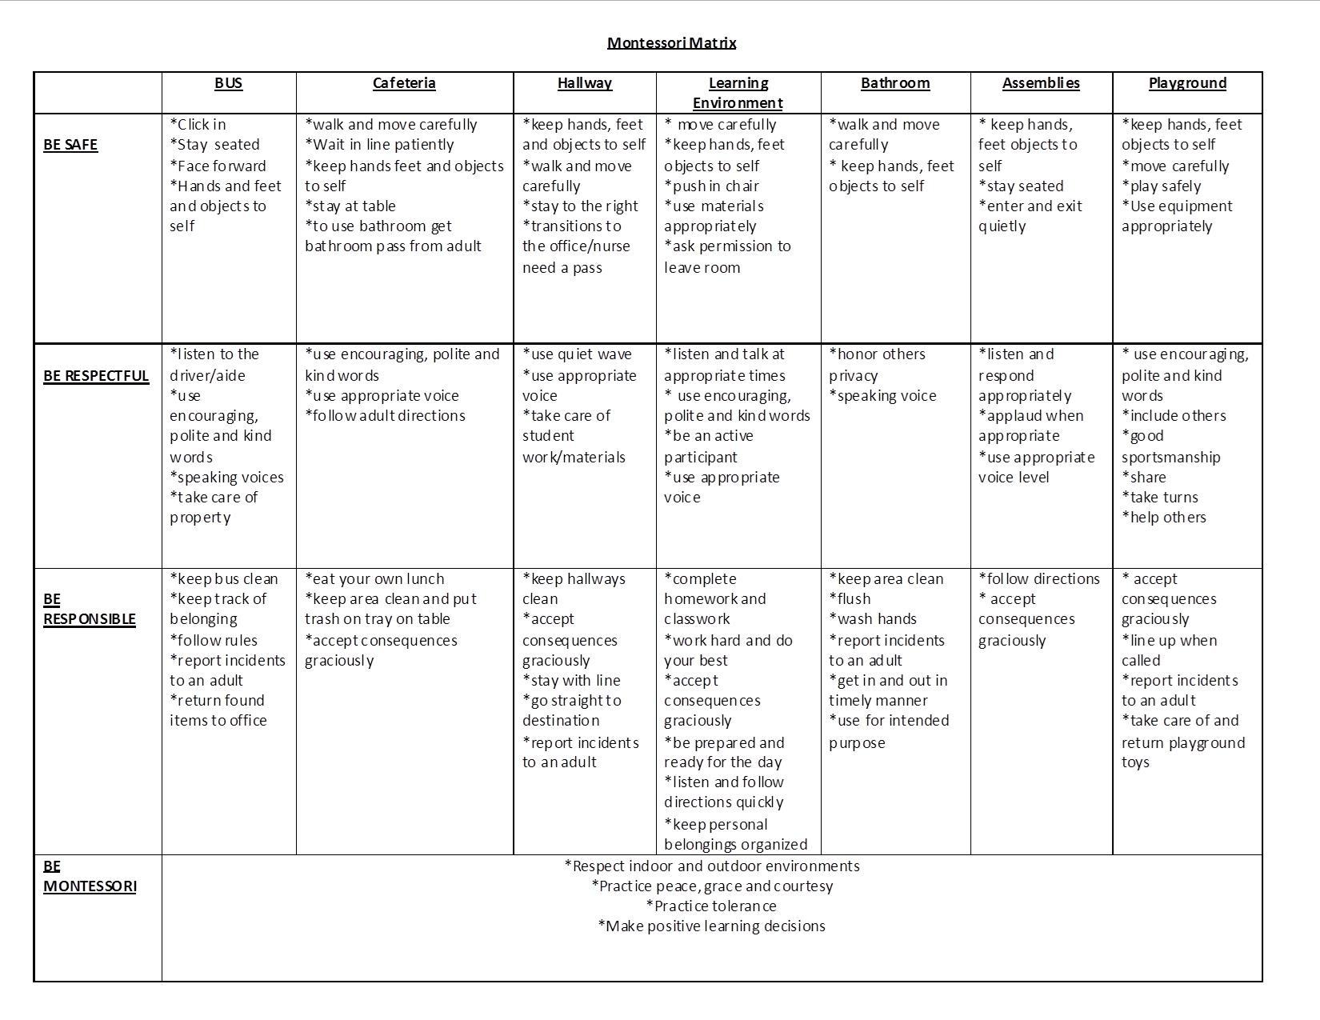

|  |  |  |
| --- | --- | --- |
|  | **Classroom Referral**  **(Minor Problem Behavior)** | **Office Referral**  **(Major Problem Behavior)** |
| **Defiance/**  **Insubordination/**  **Non-Compliance** | Brief or low-intensity failure to follow directions or talks back | High intensity (frequency and duration) of refusal to follow directions, which disrupts the learning environment |
| **Disrespect** | Low intensity, socially rude, harassing or dismissive messages to adults or students | High intensity (frequency and duration) socially rude or dismissive messages to adults or students |
| **Disruption** | Low intensity, but inappropriate disruption | Causing an interruption in a class or activity. Disruption includes sustained loud talk, yelling, screaming, or lying; noise with materials; horseplay or roughhousing; and/or sustained out-of-seat behavior |
| **Dress Code Violation** | Clothing that violates the dress code guidelines of school/district |  |
| **Inappropriate Language** | Low intensity instance of inappropriate language | Aggressive/abusive threatening verbal messages |
| **Physical Contact/Physical Aggression** | Physical Contact/Physical Aggression | Involved in mutual participation in an incident involving physical violence. Actions involving serious physical contact where injury may occur (e.g., hitting, scratching, hitting w/ an object, etc.) |
| **Property Misuse** | Low intensity misuse of property | Destruction or disfigurement of property |
| **Technology Violation** | Use of cell phone or music player | Serious, inappropriate (as defined by school) use of cell phone, music/video players, camera, and/or computer |
| **Forgery** | Student has signed a person’s name without that person’s permission (e.g., agenda, test, behavior note) | Student has signed a person’s name without that person’s permission (e.g., field trip permission form) |
| **Other** | Low intensity, socially rude, harassing or dismissive messages to adults or students |  |
| **Threat/False Alarm** |  | Student delivers a message of possible explosive materials being on campus, near campus, and/or pending explosion |
| **Bullying** |  | The continuous/repeated delivery of direct or technology-based messages that involve intimidation, teasing, taunting, threats, or name calling that result in a shift in power |
| **Use/Possession of Alcohol, Combustibles, Drugs, Tobacco, Weapons** |  | Possession or use of alcohol, substances/objects readily capable of causing bodily harm and/or property damage, illegal drugs/substances, imitations, and tobacco |

Classroom Referral vs. Office Referral

*Please see operational definitions for additional examples of problem behaviors.

VADIR Instructions

**BASIC QUESTIONS:**

|  |  |
| --- | --- |
| Where do I logon? | <https://apps.edvistas.com/vadirs/login.aspx> |
| Is there a shortcut? | Yes.  When you are on a District computer, there is a favorite called “VADIRS” |
| What is my username? | Your FULL email address (including @albany.k12.ny.us) |
| What’s the initial password? | albanycsd |
| What do I do if I have a problem such as logging on or my building is incorrect | You will need to submit an on-line technology help desk ticket.  You can do this by going to albanyschools.org and clicking on “Technology Help Desk” (under “Quick Links” on the right-hand side) |

**Video on submitting a report:**

<http://webhelp.albany.k12.ny.us/docs/howto/BEHAVIORAL_INCIDENT_REPORTING.wmv>

**Helpful Resources**

Positive Behavior and Interventions Support Website

[www.pbis.org](http://www.pbis.org)

Albany City School District Website

[www.albanyschools.org](http://www.albanyschools.org)

Association for Positive Behavior Supports

[www.apbs.org](http://www.apbs.org)