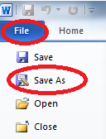
How to Use the SpEd Reports Shared Folder
- Create your FBA/Psych document in Word
- Go to File Save As

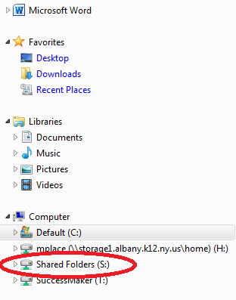

- Select the Shared Folders Drive (S:) on the left side of the
screen under “Computer”

- Double Click on the folder called “SpEd Reports”

- Look for the student’s folder (the Student ID#).

- If the folder DOES exist, double-click on the folder and then save the document in that folder.
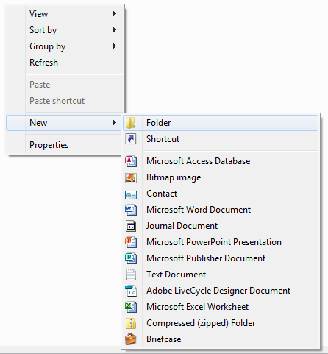
- If the student’s folder DOES NOT exist, you will need
to create a new folder.

  - Right-click anywhere in the white part of the
screen.
  - Select “New” and then “Folder”.
  - Re-name the folder using the
student’s ID number and Enter.

  - Double-click on the folder you created
to place the document inside.
  - Click save.

