K-2 REFLECTION SHEET
STUDENT FILLS OUT THIS SIDE
Student Name:
What were you doing? OTHER
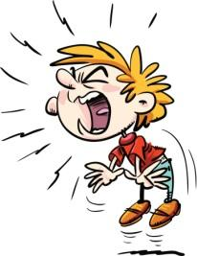 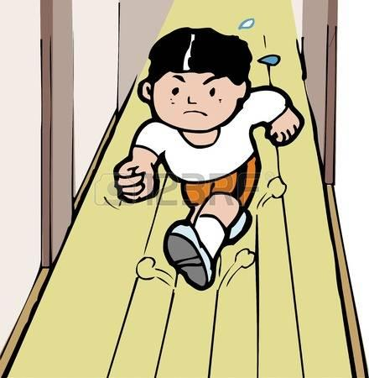 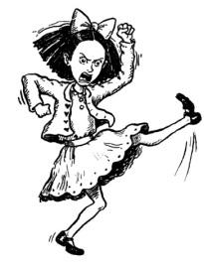 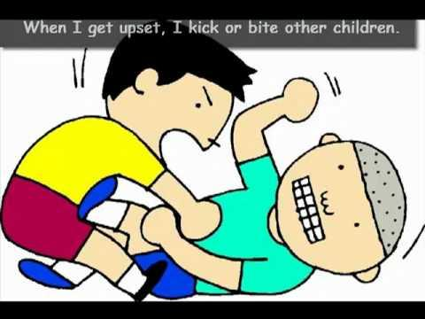 ______________________

What were you supposed to be doing?
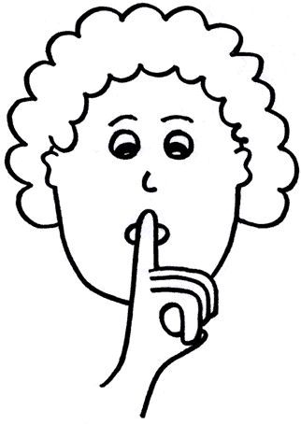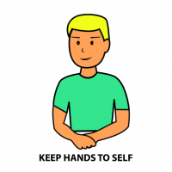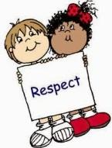
Were you doing what you were supposed to be doing?
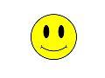
What will you do instead next time? (circle one)
Be Safe Be Responsible Be Respectful
How: ___________________________________________________

ADULT FILLS OUT THIS SIDE
Date: Time: Referring Teacher:
Classroom Teacher: Incident Location: Student:
Major (office managed) Y/N Minor (teacher managed) Y/N

Antecedent (What happened right before the behavior?)
- Academic request make of student (specify e.g., reading, long division) ___________
- Non-academic request made of student (specify e.g., read aloud, seatwork) ___________
- Other (specify): _______________________

Behavior (check box):
Leaving supervision  - Walking out  - Running in hallways  Verbal  - Yelling  - Cursing  Physical Aggression  - Pushing  - Kicking/hitting  - Throwing objects | Non-compliance  - Minor defiance  - Work refusal  Theft  - Minor

Incident Narrative (what was student supposed to be doing?):
- Sitting
- walking
- hands to self
- using objects correctly
- inside voice
- using appropriate language
- listening
- being responsible
- completing work
- Details:____________

Consequence (what happened after the behavior?):
- Conference with student
- Loss of Privileges
- Parent/family contact
- Reflection Sheet
- ISS/Cool Down
- PBIS Reteach
- Other specify):__________________________

