FUNCTIONAL BEHAVIORAL ASSESSMENT
ALBANY CITY SCHOOL DISTRICT
(Version 6/2017)

ALL SUPPORTING DOCUMENTS NEED TO BE SCANNED AND SAVED TO APPROPRIATE SHARED DRIVE (BUILDING RTI, Sp. Ed.) &/or FRONTLINE IEP

STUDENT NAME: XXXXX XXXXX |  |  |  | STUDENT DOB: 01/01/03 |  | STUDENT ID: XXXXX |  | FBA CONSENT DATE: XX/XX/18
CHRONOLOGICAL AGE: 14 | DOMINANT LANGUAGE: XXXX |  | ENL?  YES NO |  |  | SCHOOL:
 |  |  |  |  |  | GRADE:
NAMES AND TITLES OF INDIVIDUALS COMPLETING FBA (ONLY LIST THOSE THAT WERE INVOLVED IN THE FBA PROCESS)
SPECIAL EDUCATOR:  SOCIAL WORKER:  PSYCHOLOGIST: XXX XXXX  PARENT:  GENERAL EDUCATORS (LIST ALL): XXXX XXXX, YYYY YYYY, and ZZZ ZZZZ |  |  |  |  | ADMINISTRATOR:  BEHAVIOR SPECIALIST: XXXX XXXX  TEACHER ASSISTANT/AIDE:  RELATED SERVICE PROVIDERS (LIST ALL):  OTHER: XXXX XXXXX, YYY YYYYY and ZZZ ZZZZ
IS STUDENT CSE IDENTIFIED? YES NO |  | IF IDENTIFIED – CLASSIFICATION: |  |  |  |  | CLASS PLACEMENT: XXX |  | 504? YES NO

SECTION 1: EVALUATION OF TARGET BEHAVIOR
TARGET BEHAVIOR : Calling out defined as: any vocalization on or off topic that is at a volume above normal conversational level for a given setting.

DESCRIBE THE INTENSITY OF TARGET BEHAVIOR BASED ON THE RUBRIC BELOW: 1-4 (Behaviors often disrupt others in close proximity to XXXX, as well as the entire class at times.

Intensity Rubric
Intensity Rating | Definition |  | Example
1 | Behavior is confined only to the observed student. |  | May include such behaviors as: refusal to follow directions, scowling, crossing arms, pouting, or muttering under his/her breath.
2 | Behavior disrupts others in the student’s immediate area. |  | May include behaviors such as slamming textbook closed, dropping book on the floor, name calling, or using inappropriate language.
3 | Behavior disrupts everyone in the class |  | May include behaviors such as throwing objects, yelling, open defiance of teacher directions, or leaving the classroom.
4 | Behavior disrupts other classrooms or common areas of the school |  | May include behaviors such as throwing objects, yelling, open defiance of school personnel’s directions, or leaving the school campus.
5 | Behavior causes or threatens to cause physical injury to student or others |  | May include behaviors such as display of weapons, assault on others
EVALUATE PATTERNS OF TARGET BEHAVIOR BY TIME OF DAY, LOCATION, ACTIVITY, ETC. USE ANY OF THE FOLLOWING DATA SOURCES (CHECK ALL THAT APPLY):
SCATTERPLOT INTERVIEW (With: Teachers ) POINT SHEETS OFFICE REFERRAL SUMMARY FORM VADIRS OTHER:
THE TARGET BEHAVIOR IS MOST LIKELY TO OCCUR:  - WHERE (LOCATION): in the classroom, during unstructured times or in more unstructured settings  - WHEN (TIME OF DAY/ACTIVITY/CLASS): in ENL, social studies and ELA; out of seat / area occurs more frequently at the middle to end of the school day  - WITH WHOM (PEERS/ADULTS): teachers / staff |  | THE TARGET BEHAVIOR IS LEAST LIKELY TO OCCUR:  - WHERE (LOCATION): in classrooms with smaller class sizes  - WHEN (TIME OF DAY/ACTIVITY/CLASS): Math Tier II, science (more structured)  - WITH WHOM (PEERS/ADULTS): teachers with a very structured classroom management style

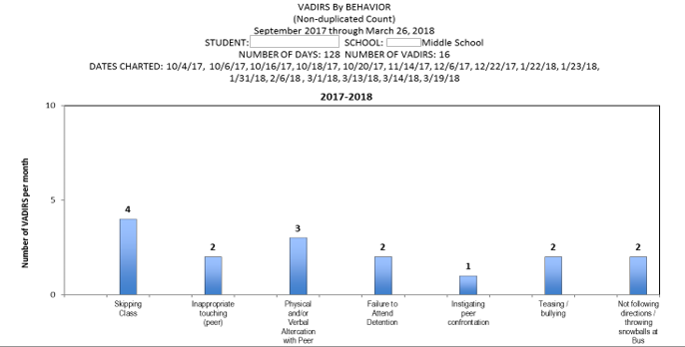

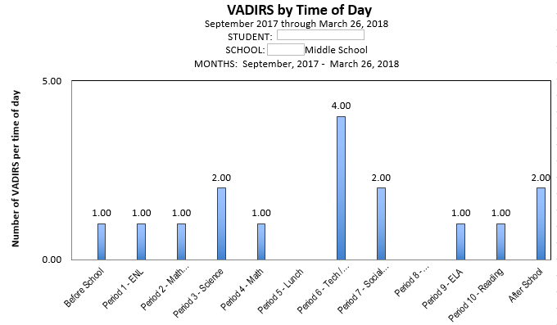

SECTION 2: EVALUATION OF CONTEXTUAL FACTORS
COGNITIVE ABILITIES
YES | NO | Does this impact the TARGET BEHAVIOR? If yes, please explain:
 |  | EXECUTIVE FUNCTIONS (flexibility, metacognition, impulsivity, inattention/distractibility, persistence, problem-solving, etc.): XXXX presents as extremely distractable - both by peers and items within the classroom. He has poor organizational skills and has difficulty persisting with classwork assigned, even when assistance is offered. Difficulty starting a task. Often requires 1 step tasks and teacher guidance to get to work.
 |  | LANGUAGE (expressive and/or receptive): Unknown - a special education referral is being submitted by the team to further evaluate cognitive abilities.
 |  | WORKING MEMORY: Unknown - a special education referral is being submitted by the team to further evaluate cognitive abilities.
 |  | MOTOR (gross and/or fine): No issues noted.
 |  | SENSORY (sensory-seeking, sensory-avoidant): No issues noted.
 |  | PROCESSING SPEED: Unknown - a special education referral is being submitted by the team to further evaluate cognitive abilities.
AFFECTIVE ABILITIES
YES | NO | Does this impact the TARGET BEHAVIOR? If yes, please explain:
 |  | MOOD (predominant or cycling): XXXX often appears to be in a good mood; joking, horseplaying and bantering with peers both in class and in unstructured environments. However, when he is not permitted to do this, he may shut down, put his head down and refuse redirection.
 |  | EMOTIONAL SELF-REGULATION:
 |  | FRUSTRATION TOLERANCE: When he is redirected consistently, he may become frustrated with the work and shut down. In a structured setting where his behaviors are more controlled, he may put his head down and refuse to participate / complete work.
 |  | SOCIAL SKILLS: XXXX is able to make and keep friends. He can be a leader; however, he has a difficult time discerning when to stop socializing / playing and get to work. He doesn't appear to distinguish between work situations and free time. He needs to work on organizational skills, focusing on classwork, instruction and interacting appropriately in a classroom setting.
MEDICAL STATUS
YES | NO | Does this impact the TARGET BEHAVIOR? If yes, please explain:
 |  | PHYSICAL/HEALTH CONCERNS/MEDICAL DIAGNOSIS:

SECTION 3: SUMMARY OF INDIRECT OBSERVATION DATA
This is a SUMMARY section. SUMMARIZE each of the following supporting documents. Do not rely on a reference to an attachment
STUDENT INTERVIEW
XXX was interviewed by Mrs. XXX (mentor for his small group intervention) on 3/1/18. XXXX states he is good at making friends and helping people out. He reports having a good sense of humor. For fun, he likes to hang out with his friends, help teachers (passing out papers, running an errand, etc), and walking around Albany with his friends. He enjoys being around his friends because they are fun and they like the things that he does. XXXX also reports that if he is mad at someone, his friends will help fix it. His favorite thing to do in school is to help people he knows. For example - when people are mad at them. He likes to help in these situations because it feels good. He reports that schoolwork is sometimes too hard, but that he can ask his friends and/or teachers for help. He reports that Mrs. XXX (ENL teacher) will tell him he is doing a good job. He would like to earn breaks so he can walk around and 'chill'. He would also like to work for social time and free time when he has finished his work. When asked about the target behavior, XXXX reports he will call out and/or get out of his seat when he is bored or if he is sitting by himself. He states that he does this to help others out and doesn't think it's fair when other people are allowed to get up and talk and he is not. He reports that he is always told to go back to his seat. He doesn't know how people at school or home can better help or understand him.

TEACHER(S) INTERVIEW(S)
Mrs. XXX, ENL teacher, completed the teacher interview form. She reports that XXXX calls out frequently and is often out of his seat. She stated that he will continue the behavior as long as he can get away with it. He will move around the room, sharpen his pencil, touch other peoples things - i.e. do anything to avoid getting started on his work. She reports the intensity of the behavior is 1-3. Setting events noted are: he may be looking for things and/or not picking up papers at the right time so he can do it later to get out of his seat. Behaviors will also occur when he is given a task and expected to work. In addition, Mrs. XXX reports that XXXX has poor organizational skills, looses everything and/or gets things out of order. The target behavior is most likely to occur in ENL, social studies and ELA. It is least likely to occur in Science because it is a more strict atmosphere. In this class, he will often put his head down and refuse to work. After the behavior starts, XXXX usually tries to interact with a peer in an attempt to get attention. Peers will respond / give him attention (passing around a phone, fist bumping). The adults will then request for him to get back to work and/or will offer him 1:1 support to get started on assignments. He has a hard time getting started on anything. He will work if someone is guiding him one step at a time, but does not work independently. Mrs. XXX feels that XXXX is trying to escape from work and/or get attention. The teachers would like him to raise his hand, wait until called on and ask appropriately if he has a question or needs to get out of his seat. Student strengths - very respectful, shows remorse appropriately, is a leader, can make and keep friends. He is artistic and can make connections to literature and articulate his thoughts orally. Student skill / performance deficits: lack of work completion, lack of attention, can't sit still, seeks attention inappropriately, writing is slow and labored, very low reading level (1st / 2nd grade), low math skills and no persistance to complete activities.
REVIEW OF RECORDS
A review of records was conducted by XXX XXXX (behavior specialist) on 2/16/18. XXXX entered XX Middle School (XMS) on 10/18/16 during his 7th grade year. Prior to entering XX, he attended YYY Middle School in YYYY. At the time he transferred to XMS, his grades in his core subjects were all 50 (Q1 of 7th grade). Teacher comments indicated that he refuses to participate in class or complete his work. In addition, it was noted that he shows minimal understanding of the content presented (ELA, Math, Science).
In 6th grade at YYY Middle School, he did not pass the following subjects for the school year: ELA, Math, Science, Social Studies, FACS and technology. Teacher comments indicates that his behavior and absences negatively affect his progress. In reading, it was noted that his effort was inconsistent and that his progress was limited due to lack of effort and reluctance to do work.
XXXX attended XMS for most of 7th grade. During that time, he received the following grades for the year: 61 (ENL), 75 (PE), 69 (Social Studies), 65 (Math), 61 (Technology), and a 76 (Science). Teacher notes stated that he needs to complete all work, put in more effort, be on time to class, and spend less time socializing. For 7th grade, he was absent 12 days and tardy to school on 21 occasions. For 7th grade, XXXX received 10 discipline referrals, 4 classroom referrals and 3 days of out of school suspension.

Current data 2017-18 - 8th grade at XMS: Behavior / Academic
Grades - for the current school year (Q1-3), XXXX has failing grades in ENL, science, technology, FACS, social studies, ELA, and reading. The only class he has passed for Q1-3 is PE. Teacher comments note that XXXX spends a lot of time avoiding work and fooling around. He also demonstrates poor effort on tasks and a lack of attention for instruction.

Discipline:
16 Discipline Referrals (see graph above for time of day / specific behaviors)
11 Classroom Referrals
3 days of in school suspension
2 days of out of school suspension

Attendance:
8 Absences, 45 Tardies to school

NWEA scores (Fall 2016-present):
Reading:
WI 17: 167 (1st percentile)
SP 17: 177 (1st percentile)
FA 17: 187 (3rd percentile)
WI 18: 194 (5th percentile)
Math:
FA 16:200 (9th percentile)
WI 17: 186 (1st percentile)
SP 17: 179 (1st percentile)
FA 17: 189 (2nd percentile)

NYSESLAT (16-17) - Expanding Level

PARENT/GUARDIAN INTERVIEW
XXXX's father, ZZZ ZZZ, was interviewed by Mrs. XXX. When asked about the target behavior, Mr. ZZZ reported that XXXX just wants to play. When not supervised, he will go back to playing. Mr. ZZZZ reports that the household consists of himself, his wife, XXXX, 2 brothers and 4 sisters. He reports that XXXX enjoys playing on his phone and with his siblings. Again he reports that everything is play for XXXX. When asked about strengths, he stated that XXXX is artistic and likes to work with his hands. Socially, he is a leader and enjoys the social scene at school. Mr. ZZZ notes that a difficult task may affect

XXXX's behavior. He reports no diagnosis or medication for XXXX. He did state that XXXX may have had a behavior assessment when he was in YYYY, but there was no idication of this in his school folder. No eating or sleep issues were noted. No development difficulties were indicated.

Ms. YYY, behavior specialist, contacted YY Middle School on 3/29/18 to determine if a previous behavior plan and/or assessment had been done. According to XX XXXX, guidance counselor, no behavioral assessment was done for XXXX while he was in their district.

SECTION 4: SUMMARY OF DIRECT OBSERVATION DATA
Baseline Data Collection Method
SELECT ONE MEASURE – DOCUMENT A MINIMUM OF 8 DATA POINTS
TIME SAMPLING  (CHECK ONE)  WHOLE INTERVAL  PARTIAL INTERVAL  MOMENTARY |  | FREQUENCY DATA | DURATION DATA | LATENCY DATA
QUANTITATIVE Summary of Baseline Data
Observations were conducted in both problem and non-problem settings: YES NO
Summary of findings: Based on the 27 observations conducted for this assessment, XXXX was calling out on average 6 times per class period. The estimate average work completion during the data collection period was 7% of assignments given.

In addition to the data collection listed above, XXXX has received 16 discipline referrals for the 2017-18 school year, resulting in 2 days of out of school suspension and 3 days of in school suspension. Four of the sixteen discipline referrals (25%) were for skipping class (i.e. out of area). Three of four of the referrals for skipping class occurred during 6th period, which is an elective class (technology and/or facs).

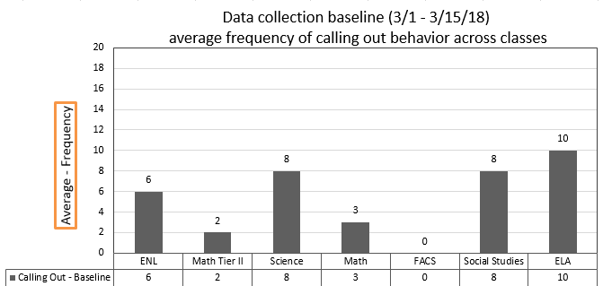

Optional Additional and Supplemental Baseline Data
PERMANENT PRODUCT | Summary of findings:

SECTION 5: HYPOTHESIS
Complete following section using Antecedent-Behavior-Consequence data
What antecedents occurred before the target behavior?  Summary of findings:  -asked to complete activity (reading passage) and answer questions  -expected to be working on assignment  -noisy environment  -peers talking to him  -being given directions for task | TARGET BEHAVIOR  (Copy and paste your Target Behavior here)  Calling out defined as: any vocalization on or off topic that is at a volume above normal conversational level for a given setting. |  | What consequences occurred after the target behavior?  Summary of findings:  -peers made comments back or to tell him to stop  -verbal redirection to task / adult reminders  -peers laughing  -avoided completing task  -asked to move seats
What is the function of the target behavior?
Select a minimum of 1 function – if select more than one function, interventions must address both functions
TO GET:  ATTENTION (ADULT/PEER)  TANGIBLE (OBJECT/ACTIVITY)  SENSORY |  | OR |  | TO AVOID/ESCAPE:  ATTENTION (ADULT/PEER)  TANGIBLE (OBJECT/ACTIVITY)  SENSORY
Hypothesis Statement
WHEN THIS OCCURS (describe the circumstances/setting events) When given a task to complete, when environment is noisy and/or peers are making comments to him,

THE STUDENT DOES (describe the target behavior) XXXX will call out

TO GET/AVOID (describe the consequences) to gain attention from peers or teacher.

SECTION 6: ASSESSMENT OF STUDENT PREFERENCES FOR REINFORCEMENT
What assessment(s) was used to determine student preferences for reinforcement? Check below.
Forced Choice Reinforcement Menu Student Reinforcement Survey If no student participation, specify reason:
INCENTIVES (Summarize results): XXXX indicated the following for potential reinforcers:  -water, juices  -bagels, chips, pizza, fruit  -time with a friend / preferred staff  -peer tutor, group work  -break in the hallway  -school supplies, stickers, stress ball  -time to draw  -computer time / free time  -having work display / good grades  -teacher praise  -earning points / tickets  -doing easy work by himself | DISINCENTIVES (Summarize results): -negative phone calls home

SECTION 7: DOES THIS STUDENT’S BEHAVIOR WARRANT A BIP BASED ON FBA INFORMATION COLLECTED & ANALYZED?
MEETING DATE: 3/23/18
ATTENDANCE: XXXX, XXXX, XXX and XXXX

MEETING DECISION
NO  IF NO, YOU DO NOT NEED TO CONTINUE WITH THE REMAINDER OF THE DOCUMENT. PLEASE PROVIDE A BRIEF SUMMARY STATEMENT OF WHY YOUR FINDING IS THAT A BIP IS NOT INDICATED AT THIS TIME: | YES  IF YES, PLEASE CONTINUE WITH REMAINDER OF THE FBA DOCUMENT

SECTION 8: RECOMMENDATIONS FOR TEACHING ALTERNATIVE SKILLS OR BEHAVIORS
REPLACEMENT BEHAVIOR: Break card / 'I need help' card - XXXX will use his break /help card to ask for a break appropriately and/or to ask for assistance / attention.
GOAL BASELINE: XXXX will meet his goal when his call-outs are reduced from 6 times / class period to 2 or less per class period.
SETTING EVENT STRATEGIES:  -Preset classroom expectations  -Greet at the door / provide non-contingent praise at the beginning of the class period. | STRATEGIES TO TEACH ALTERNATE BEHAVIORS:  -teach proces for replacement behavior, including how to interact appropriately in the classroom [provide opportunity for modeling, practice and discussion)
ANTECEDENT STRATEGIES:  -Provide choice of assignment at instructional level.  -Classroom job.  -Break/ help card - outline specific parameters for break and assistance (what it looks like, what happens when he needs to wait, etc.) | CONSEQUENCE STRATEGIES:  -structured consequences for when XXXX is exhibiting the target behavior  -when demonstrates successful use of the replacement behavior, he will earn a reward at the end of the class period  -frequent contingent verbal reinforcement when demonstrating the replacement behavior

