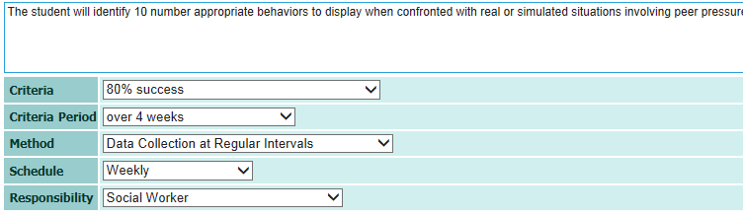
Criteria  - Where you expect the student will be at the end of the school year OR  - what the criteria is at which the student has demonstrated mastery | Actual Criteria student demonstrated in session each week: |  |  |  |  |  | Identified between 4 and 6 correct per week for this criteria period
 | 4/10 = 40% | 5/10 = 50% |  | 4/10 = 40% | 6/10 = 60%
Criteria Period  The period of time OR number of sessions over which you will decide if mastery has been achieved | 4 WEEKS
Method  How you will collect the data | Student will be asked to verbally identify 10 appropriate behaviors | Student will be asked to verbally identify 10 appropriate behaviors | Student will be asked to verbally identify 10 appropriate behaviors |  |  | Student will be asked to verbally identify 10 appropriate behaviors
Schedule  This is the Data Point you are going to chart on your graph | One time a week  (10/4/14) | One time a week  (10/10/14) | One time a week  (10/17/14) |  |  | One time a week  (10/24/14

NAME:
GOAL:
The student will identify 10 appropriate behaviors to display when confronted with real or simulated situations involving peer pressure.
CRITERIA:
80% correct over a 4 week period measured one time a week using verbal interview with student during counseling session

September | Week 1  DATE: | Week 2  DATE: | Week 3  DATE: | Week 4  DATE: | Average % Correct
October | Week 1  DATE: 10/4 | Week 2  DATE: 10/10 | Week 3  DATE: 10/17 | Week 4  DATE: 10/24 | Average % Correct
 | 4/10 | 5/10 | 4/10 | 6/10 | 45% correct over 4 weeks
November | Week 1  DATE: | Week 2  DATE: | Week 3  DATE: | Week 4  DATE: | Average % Correct
December | Week 1  DATE: | Week 2  DATE: | Week 3  DATE: | Week 4  DATE: | Average % Correct
January | Week 1  DATE: | Week 2  DATE: | Week 3  DATE: | Week 4  DATE: | Average % Correct
February | Week 1  DATE: | Week 2  DATE: | Week 3  DATE: | Week 4  DATE: | Average % Correct
March | Week 1  DATE: | Week 2  DATE: | Week 3  DATE: | Week 4  DATE: | Average % Correct
April | Week 1  DATE: | Week 2  DATE: | Week 3  DATE: | Week 4  DATE: | Average % Correct
May | Week 1  DATE: | Week 2  DATE: | Week 3  DATE: | Week 4  DATE: | Average % Correct
June | Week 1  DATE: | Week 2  DATE: | Week 3  DATE: | Week 4  DATE: | Average % Correct

